Open Shelly app

**Log in** if not already

Global SPECIALIST APPS ONLY user

*** DO NOT DISTRIBUTE TO CUSTOMERS ***

un: shellymanager@specialistapps.com

pw: $hellyM4n4g3r

Add new device

Add via Wi-Fi (AP Scan)

- If it doesn't appear, it may already be added, so change dropdown from "New devices" to "All devices" and it should show up

Follow instructions to select Wi-Fi network and complete setup

If you cannot see the Shelly Device, you may need to connect to it manually, and ensure Wi-Fi is enabled. When Shelly is connected and powered up, you should see its WiFi eg **ShellyPlus1-XXXXXXXXXXXX**

**Connect** to this WiFi

When you have connected to the Shelly Access Point Wi-Fi, go to **http://192.168.33.1/**

Tap **WiFi icon** up top

Make sure **"Enable Wi-Fi network"** is **checked**

**Save** settings

Tap **Cloud** icon up top

Make sure **"Enable cloud"** is **checked**

**Save** settings

Shelly device should now be visible in Shelly app, so tap on it

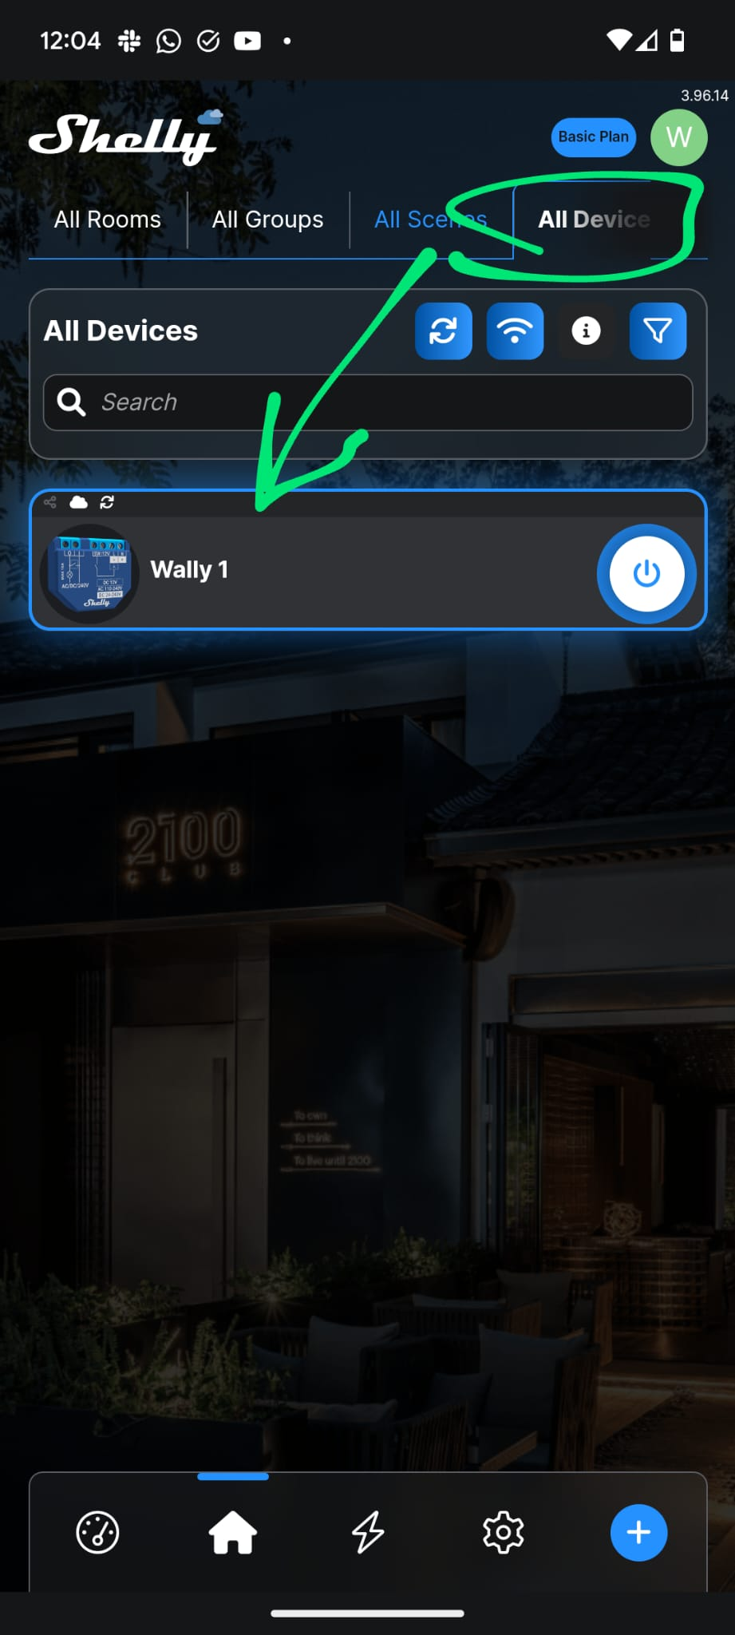

Select the **Network** tab

Ensure **"Access point"** is **Enabled**

**Uncheck "Open network"**

Set the password to: **APM4n4g3r**

IMPORTANT - the password MUST be set to the above password

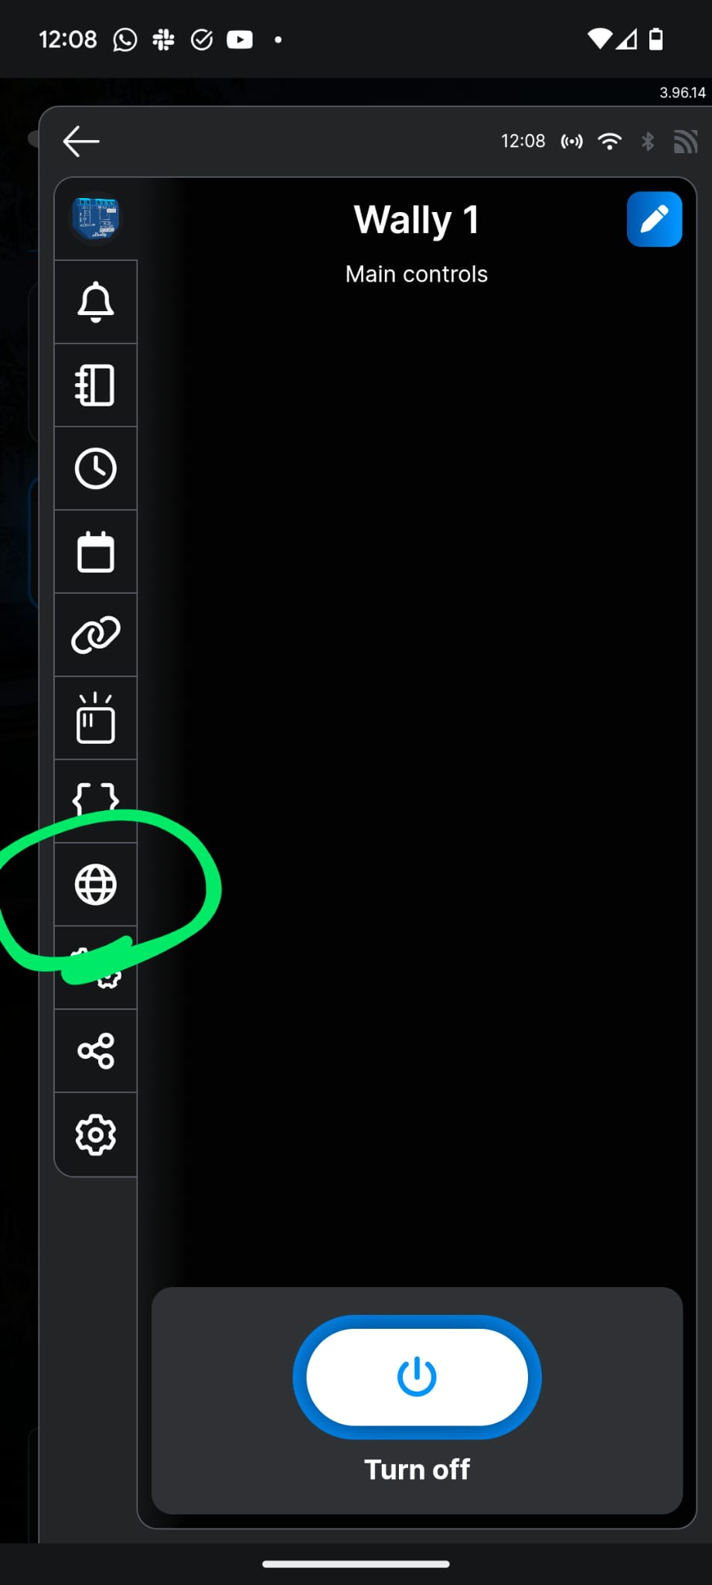 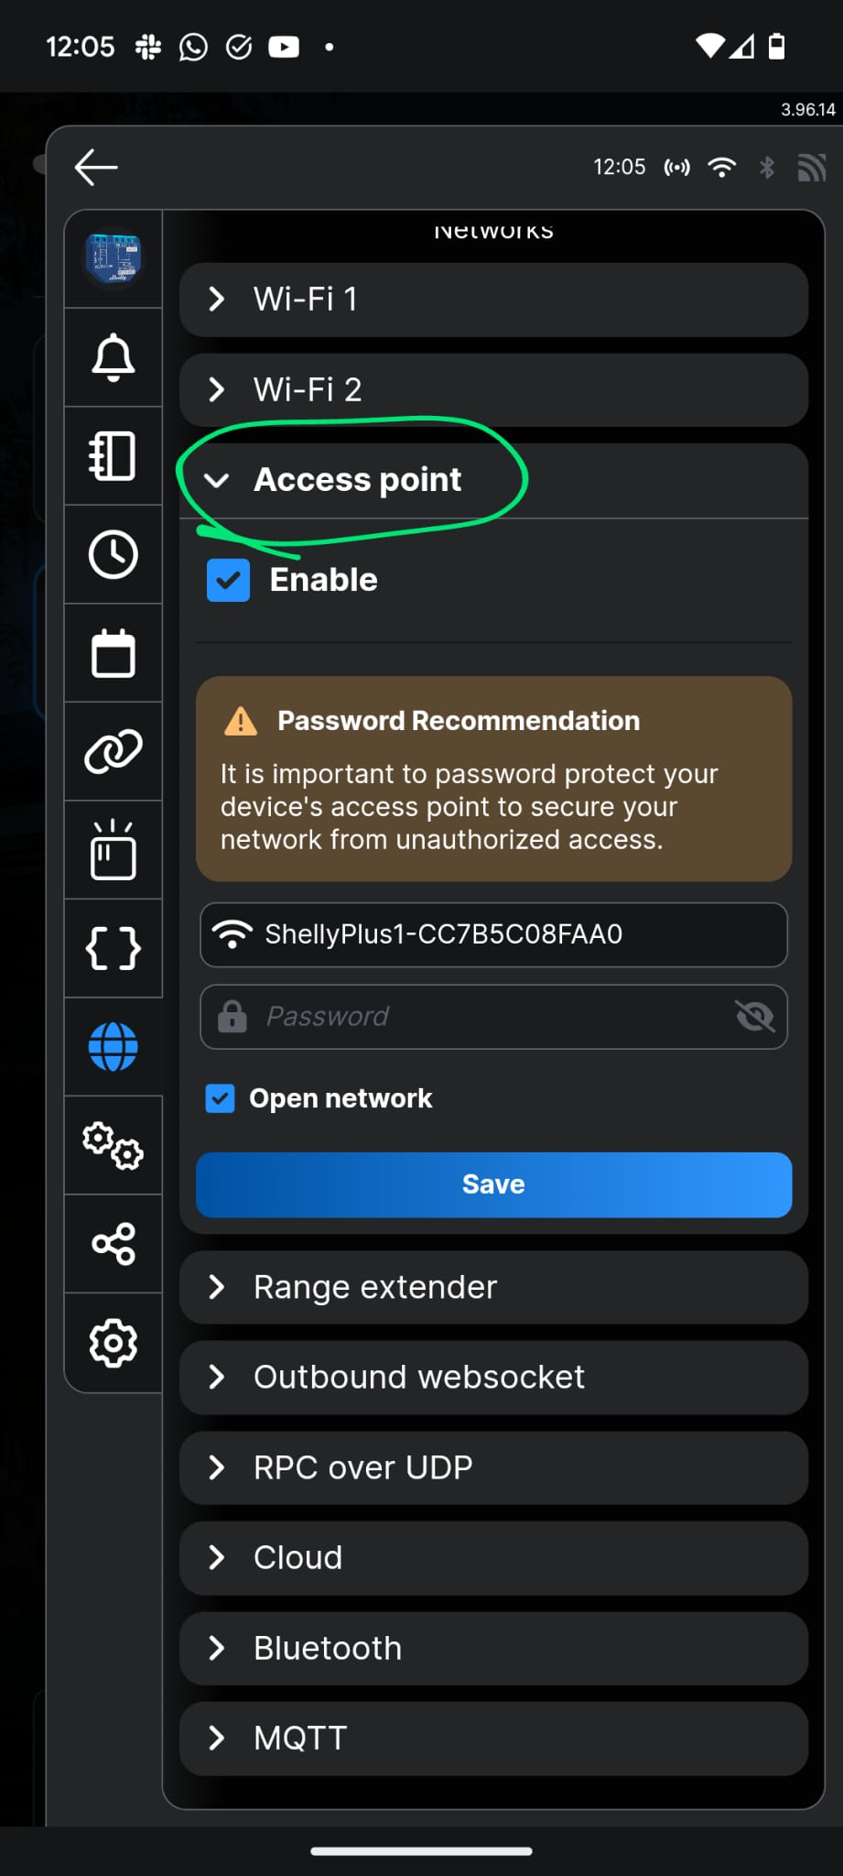

Ensure **"Cloud"** is **Enabled** and **Connected**

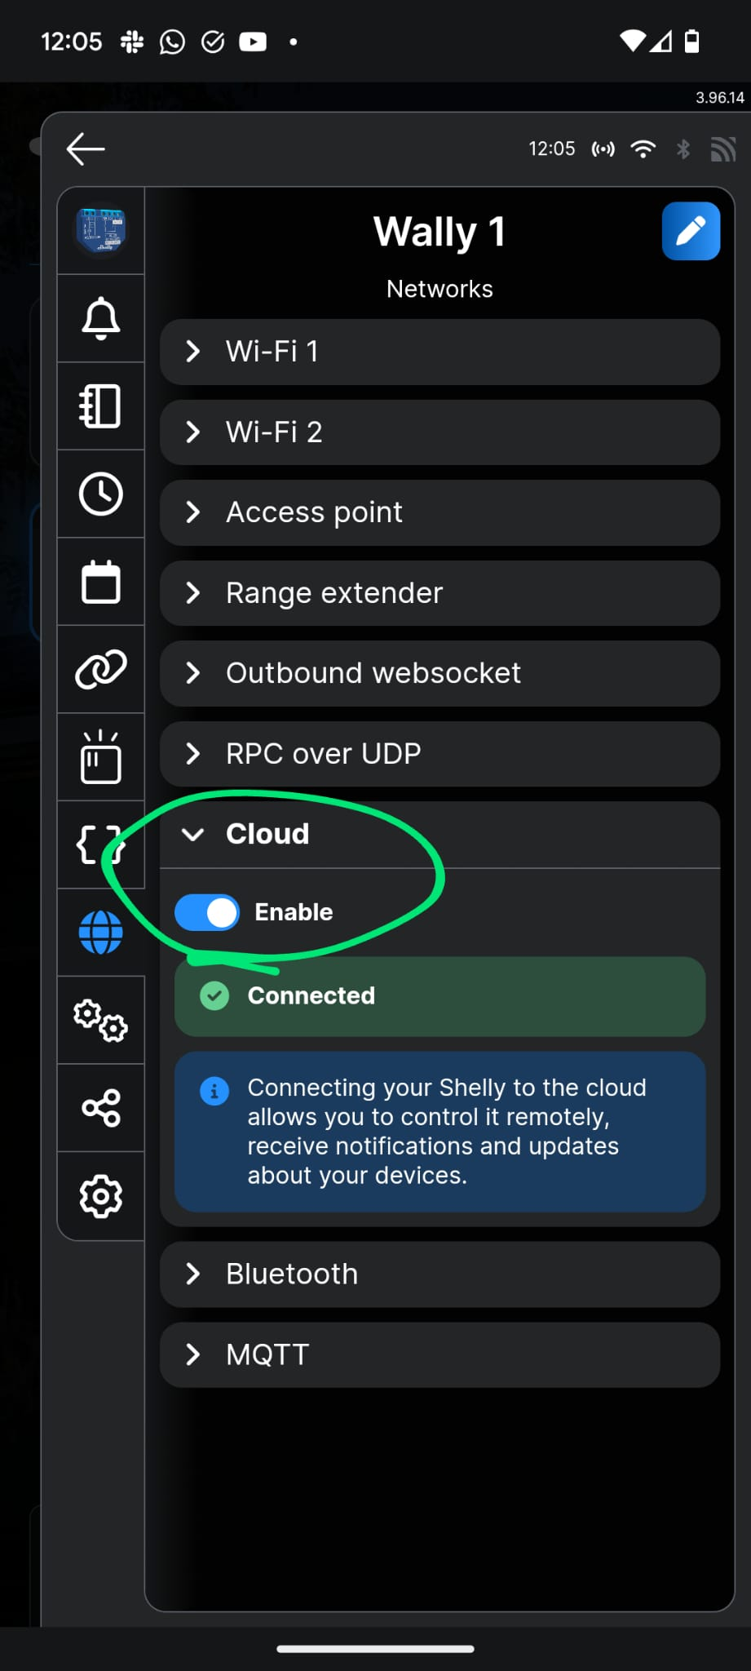

Select the **Settings** tab

Select **"Input/output settings"**

Select the option to **"Turn ON when it has power"**

**Save** settings

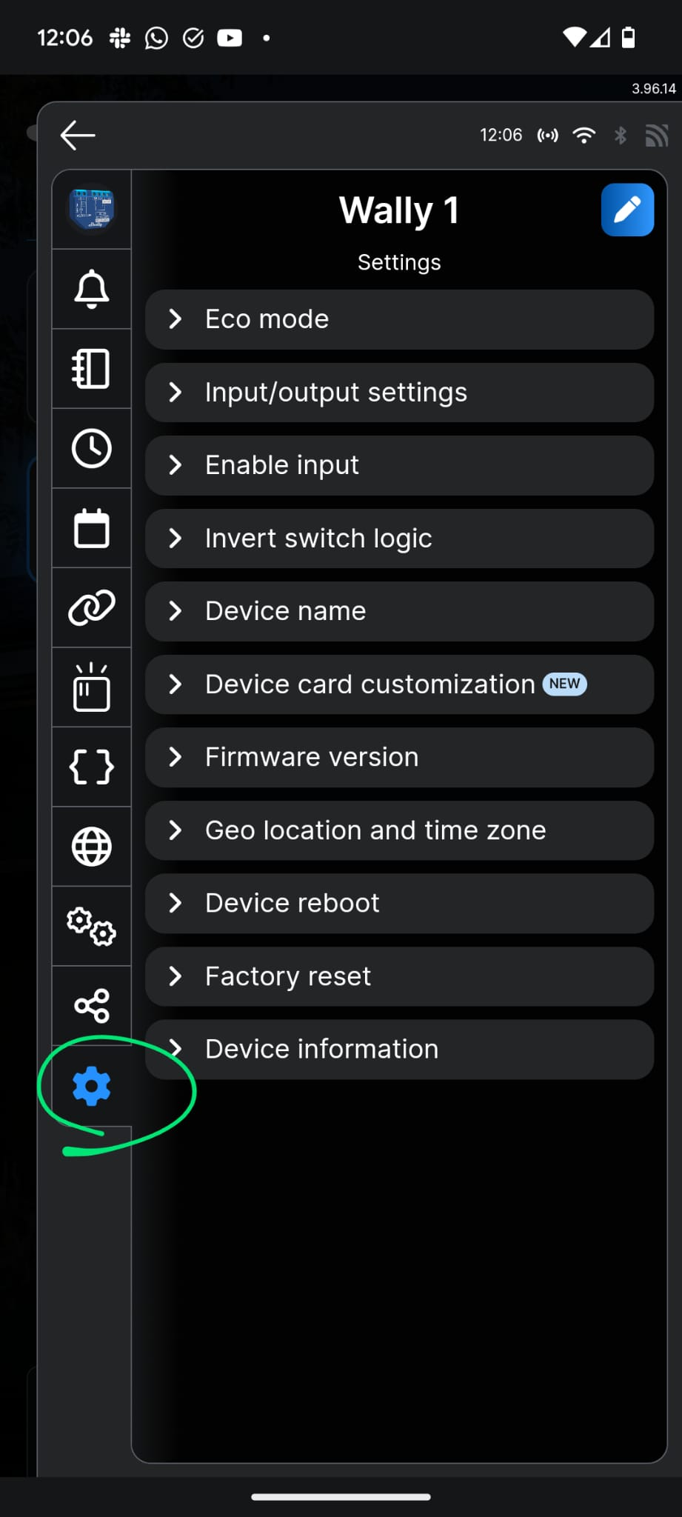 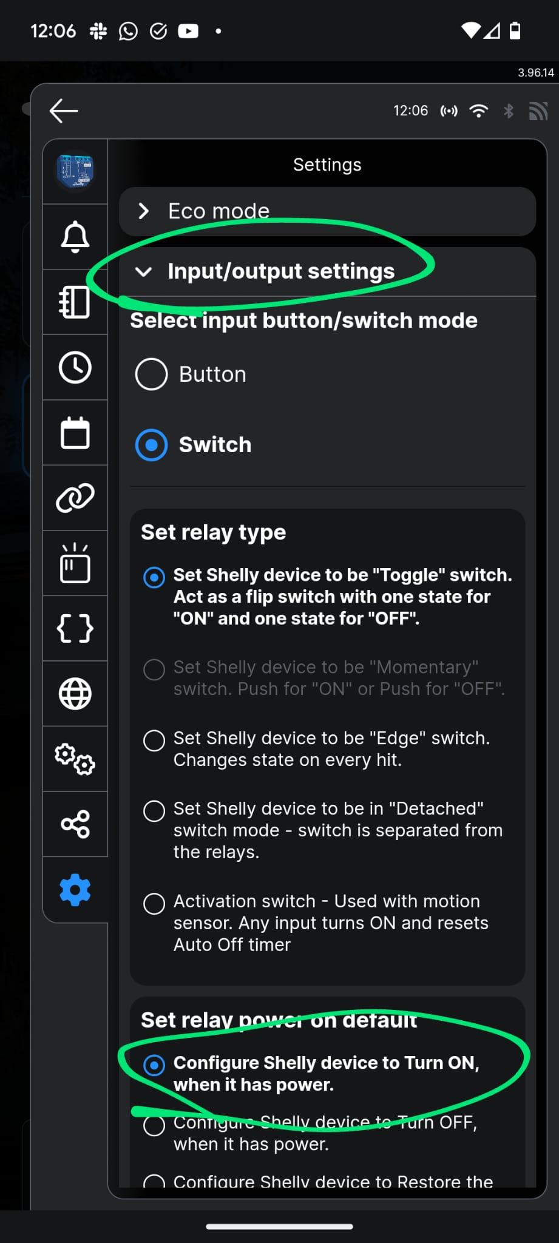

Select **"Device information"**

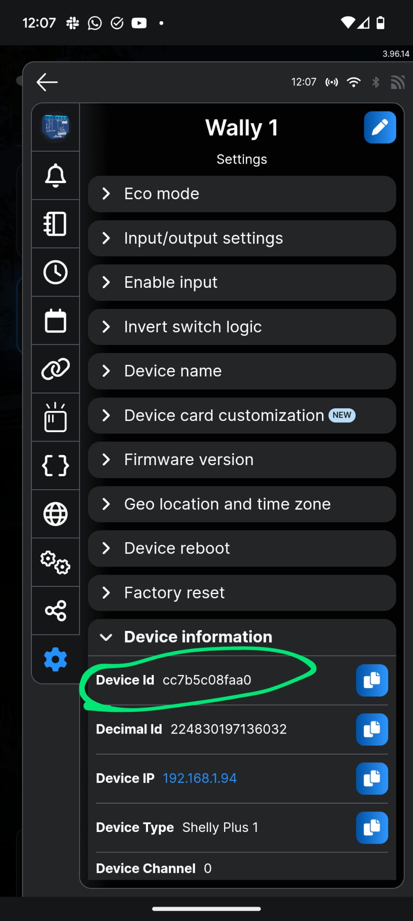

Make note of the **Device ID** to log against the Kiosk / Customer, so we know which Shelly device is in which Kiosk

Send us the Device ID and which customers Kiosk it is installed inside