1) Install the Kiosk Updater app from the following location:

https://mobileapps.specialistapps.com/kiosk/Generic%20Installer/app-release.apk
or
https://tinyurl.com/saFactoryUpdater

2) The Kiosk needs to be connected to the internet. Once connected, tap Next

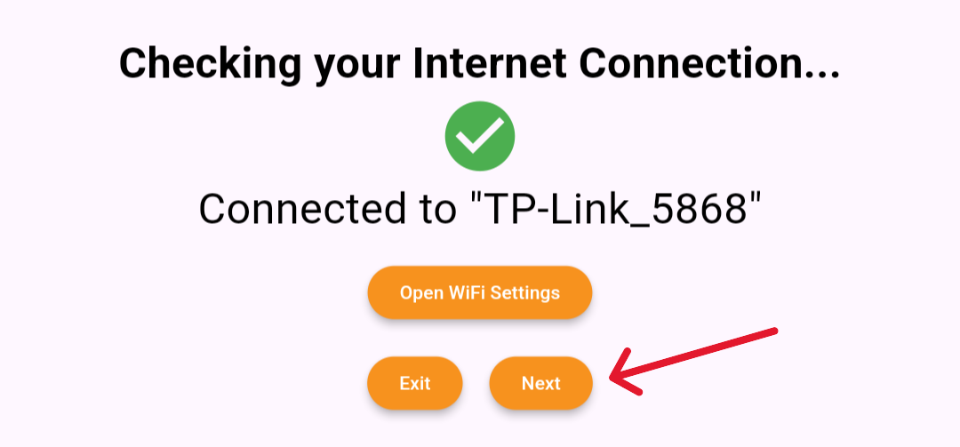

3) The Kiosk will attempt to register, and if successful, will display the Registration ID

4) Print this ID and Attach to Kiosk

5) TELL US which ID relates to which Kiosk
eg
7206 – 55’’ Off Grid
5628 – 32’’ Indoor
2439 – 32’’ Outdoor



